Study of a terminal based text editor such as Vim or Emacs. (By the end of the course,
students are expected to acquire following skills in using the editor: cursor operations,
manipulate text, search for patterns, global search and replace)
Basic Linux commands, familiarity with following commands/operations expected
1. man
2. ls, echo, read
3. more, less, cat,
4. cd, mkdir, pwd, find
5. mv, cp, rm ,tar
6. wc, cut, paste
7. head, tail, grep, expr
8 chmod, chown
9. Redirections & Piping
10. useradd, usermod, userdel, passwd
11. df,top, ps
12 ssh, scp, ssh-keygen, ssh-copy-id

1. man

Man command in Linux is used to display the user manual of any command that we can run on the terminal. It provides a detailed view of the command which includes NAME, SYNOPSIS, DESCRIPTION, OPTIONS, EXIT STATUS, RETURN VALUES, ERRORS, FILES, VERSIONS, EXAMPLES, AUTHORS and SEE ALSO.

Syntax : $man [OPTION]... [COMMAND NAME]... Options and Examples 1. No Option: It displays the whole manual of the command
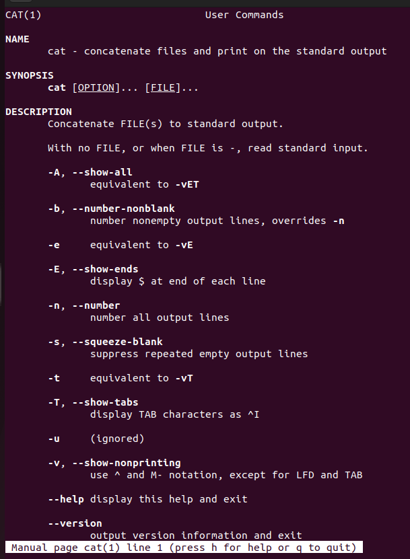
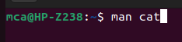
Syntax : $ man [COMMAND NAME]
2. ls, echo, read

LS

ls is a Linux shell command that lists directory contents of files and directories. It provides valuable information about files, directories, and their attributes.
Syntax of `ls` command in Linux

ls [option] [file/directory]

ECHO

The echo command in Linux is a built-in command that allows users to display lines of text or strings that are passed as arguments. It is commonly used in shell scripts and batch files to output status text to the screen or a file.
Syntax of `echo` command in Linux

echo [option] [string]

READ

The read command in Linux is an in-built command-line utility that is primarily used for accepting user input or reading a line of input from a standard input (stdin).

Read [file name]

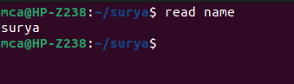

3. more, less, cat,

more

The more command reads files and displays the text one screen at a time. The command pauses after each screen and prints the word More at the bottom of the screen. If you then press a carriage return, the more command displays an additional line.
Syntax:more [file name]

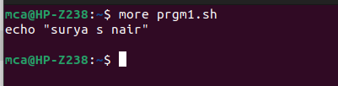

less

The 'less' command reads the file one screen at a time, allowing you to navigate through it without loading the entire file into memory. In terms of related commands, the 'less' command is part of a family of commands in Linux that are used for viewing and manipulating text

syntax:less [options] filename

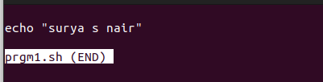

cat

The cat command on Linux concatenates files together. It's often used to concatenate one file to nothing to print the single file's contents to the terminal. This is a quick way to preview the contents of a text file without having to open the file in a large application

syntax:cat [OPTION] [FILE]

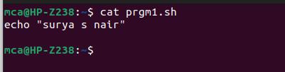

4. cd, mkdir, pwd, find

cd

Linux cd command is used to change the current working directory ( i.e., in which the current user is working). The "cd" stands for 'change directory.' It is one of the most frequently used commands in the Linux terminal.

Syntax:cd <dirname>
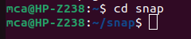

mkdir

The mkdir command in Linux/Unix is a command-line utility that allows users to create new directories.

Syntax:mkdir <dirname>
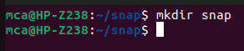

pwd

The "pwd" command prints the full name (the full path) of current/working directory.
Syntax:pwd [OPTIONS]
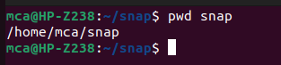

5. mv, cp, rm ,tar

